Documentary l Culture l Coastal transformation l Black Sea l Vienna l The Hague l Sinop l Istanbul

28th of October 2012

“Artist in Residency” from Sinop/TR to The Hague/NL

XsentrikArts: Bahanur Nasya (architect) and Yilmaz Vurucu (writer/producer/director) www.xsentrikarts.com

THE SEA IN ME
İçimdeki deniz
genre: documentary
running time: 60 minutes
pre-production: June 1-July 15, 2012/Vienna/AT
production: July 15-September 1, 2012/Sinop/TR
post-production: September - November 2012/Vienna/AT & The Hague/NL
directed by: Yilmaz Vurucu
produced by: Bahanur Nasya

XsentrikArts is an interdisciplinary arts platform. Following extensive research on the culture, architecture and history of the area, the team was selected to participate in the artist in residency program to produce the documentary ”The Sea in me” in Sinop, a small town on the coast of the Black Sea.

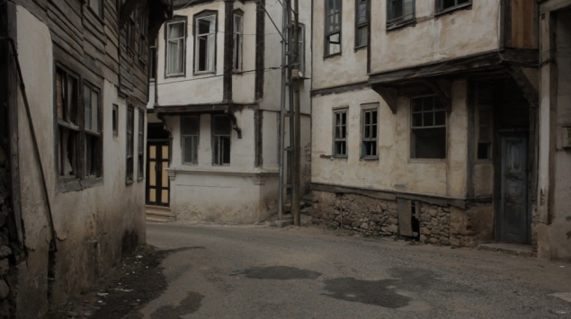
‘Coastal living is a privilege which carries along with it, big responsibility. We had assumed that we would be able to discover local culture and obtain information about the modern challenges facing the city by following its residents and the Sinopese proved us right. Every person interviewed gave us information on different aspects of these issues, and helped us obtain an overview of the dynamics of the city. We hope to be able to strengthen the exchange and help them carry their culture into the future.’ Bahanur Nasya.

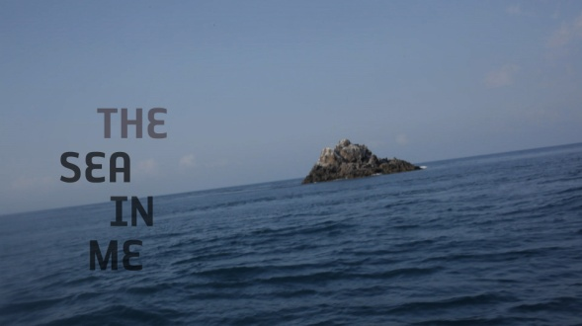
The XsentrikArts team shot the documentary “The Sea in me” in Sinop/TR during their artist-in-residency period, between July 15th and September 1st. Dozens of Sinopese will be sharing their troubles and hopes with the rest of the world. The goal is to use Sinop as an example for the coastal transitions and reveal its effects on the citizens. Tangled topics include rapid urbanisation, unbalanced development, migration and social change.

Following the production, they had just enough time to complete a montage of the preview, and screened it to the Sinop public on August 23rd, 2012 in “Sinop hal binasi” and received excellent feedback from the locals. The preview was also screened from August 24 to September 12 as part of the Sinopale exhibition in the historic prison of Sinop/TR. XsentrikArts is now guests at the DCR Guestudios in the Hague/NL as artists-in.residence once again, where they’re working on completing the postproduction of the documentary. „The sea in me“, will be premiered on the 4th of November in museon, The Hague, followed by a debate with experts about cultural and coastal transitions. On the 6th of November a second screening will follow, accompanied by an artist’s talk, focusing on the role of arts and artists in transition phases. Permanent screening at the “now wakes the sea”-exhibition in Istanbul Siemens Sanat will follow by the end of the year.

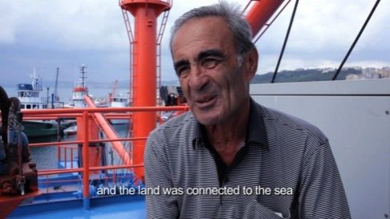
‘Centuries of co-existing with nature and the sea have created a rich and vibrant culture, one which needs to be maintained and not sacrificed to the norms of what we define as global modernity. In order to reveal the culture and the challenges facing the locals, we followed fishermen effected by the change in the sea climate, artists stuck in the inhospitable economic environment of a small coastal town, a family which lost a loved one over 30 years ago in a tragic sea accident, alongside the stories of many others. Thanks to generosity of the Sinopese, we captured life from a very personal angle, and hope that it will help raise awareness on coastal cultures and current developments.’ Yilmaz Vurucu

‘The Sea in me’ is initiated by the Dutch Satellietgroep in cooperation with the Turkish Europist/Sinopale. Both associations aim to increase artistic and cultural Exchange. Sinopale takes place every second year, and helps connect the locals of Sinop with international artists and their works. Satelietgroep is putting together a sea archive of documentaries and videos, which will be presented as a touring film festival in various coastal towns. Austrian based XsentrikArts combines different expertises to produce motion media projects, mostly about their favourite themes of personal and communal perception.
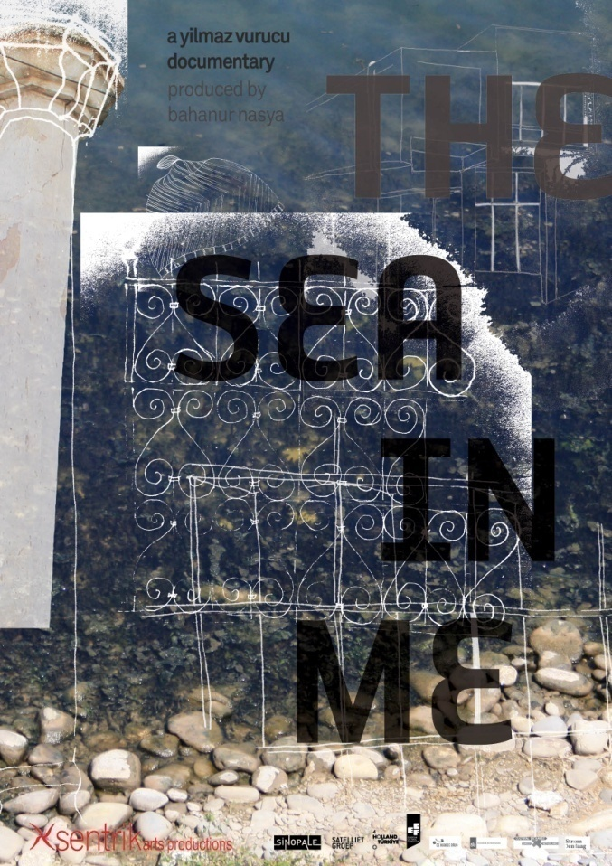

Premiere: 4.11.2012 13.00 - 14:00
Museon, Museum for Culture and Science, Stadhouderslaan 37, The Hague/NL

Screening: 6.11.2012 17:30 – 22:00
Gemak, Paviljoensgracht 20-24, The Hague/NL

Exhibition: December 12 – January13
Siemens Sanat Galerisi, Istanbul/TR

curators:
NL/Now Wakes The Sea (NWTS):
Jacqueline Heerema, Ronald Boer (landscape architect), Eliane Esther Bots (artist/filmmaker)
TR/SINOPALE:
Mahir Namur, Melih Görgün and the team of Sinopale 4.
®2012 XsentrikArts. All rights reserved.
www.xsentrikarts.com
http://www.facebook.com/TheSeaInMe

contact:
Bahanur Nasya
xsentrikarts@hotmail.com

